Mortality Table
This project aims to build a mortality table for all deaths in the USA. Mortality tables are essential for actuarial modeling ……. Explain with actual examples.

Data Acquisition
Go to the CDC wonder website and select Underlying Cause of Death and select 1999-2020: Underlying Cause of Death by Bridged-Race Categories



Following were the options selected to extract the data necessary for this project.

Group each mortality data (death, population, crude rate=death/population) by year, age, sex.
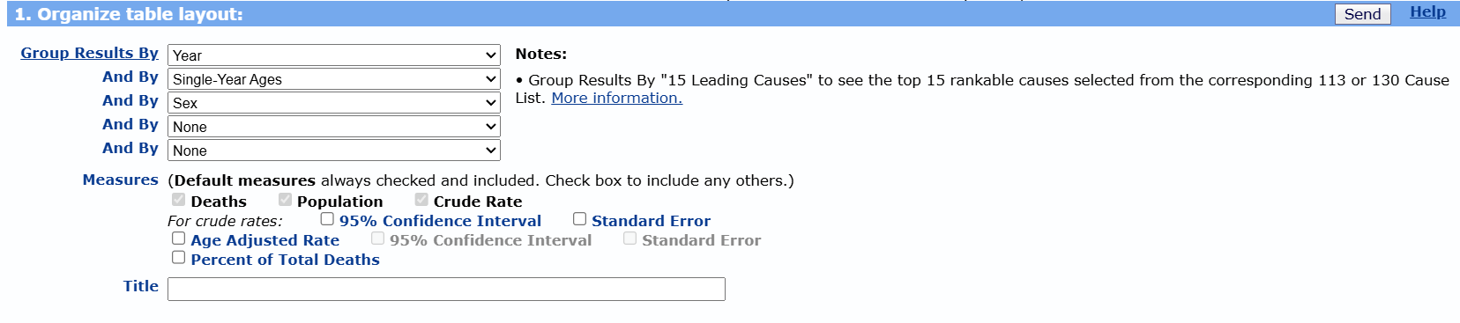
All states=USA level data + All areas
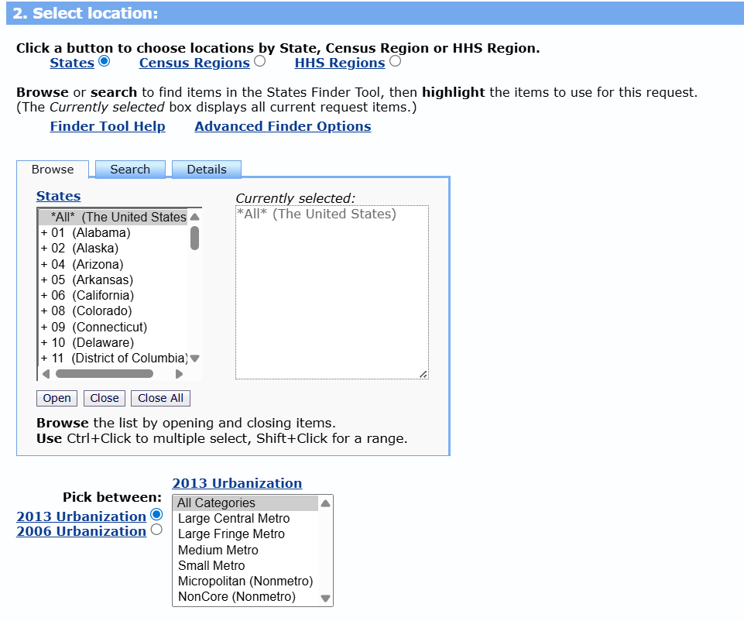

Include all ages, …, race.
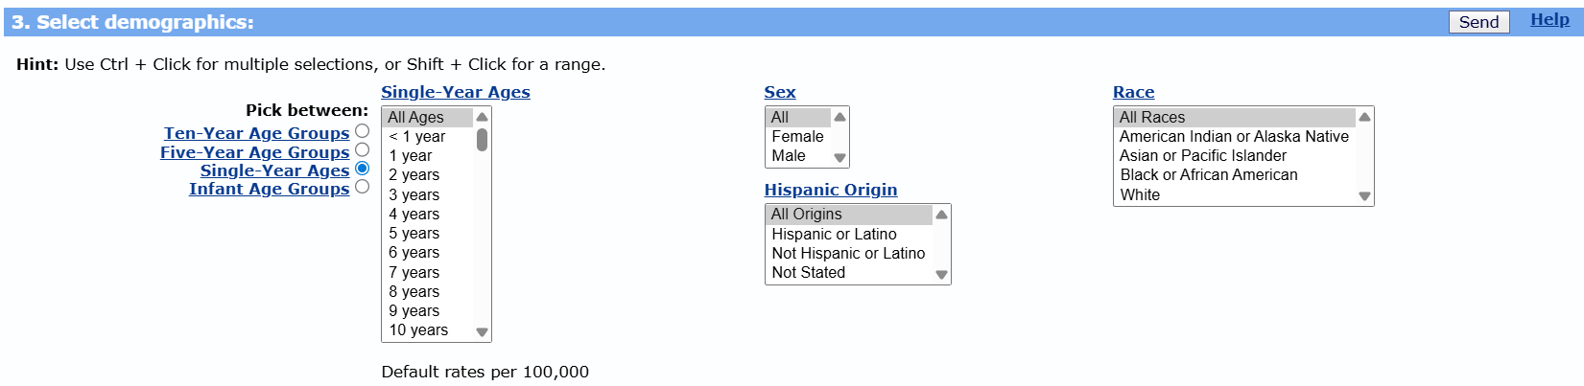

Narrow down to only years 2015-2020 for now
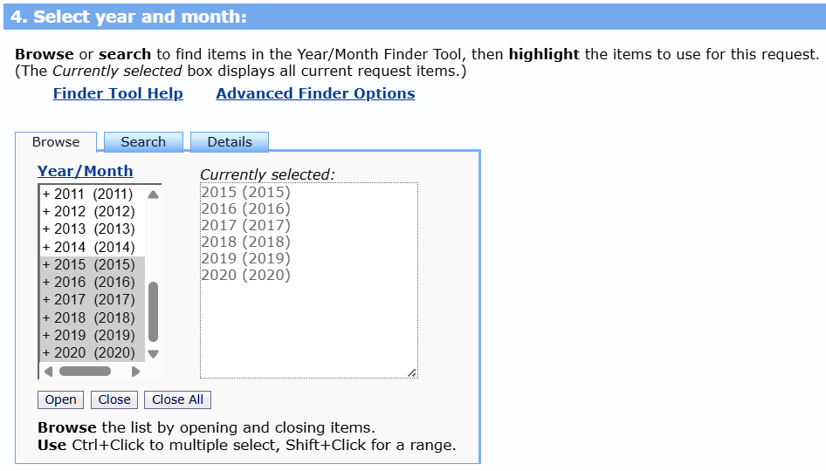

No specification for weekday, autopsy, place of death.
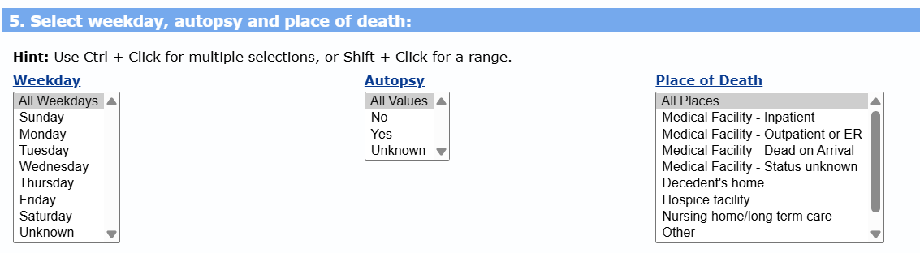

Include all causes of death
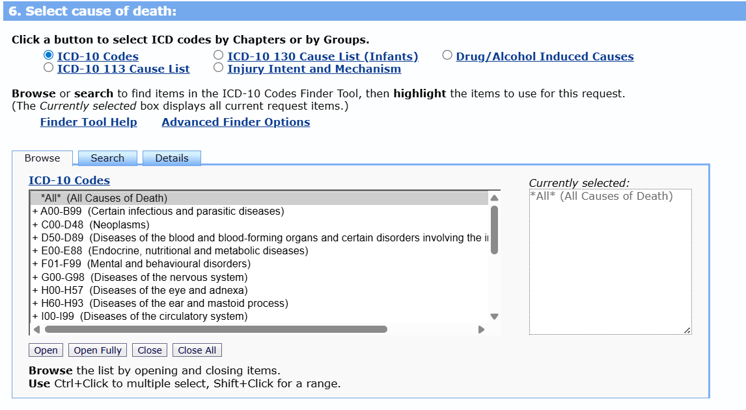

Download as CSV file, show suppressed values, 3 decimal places, etc.
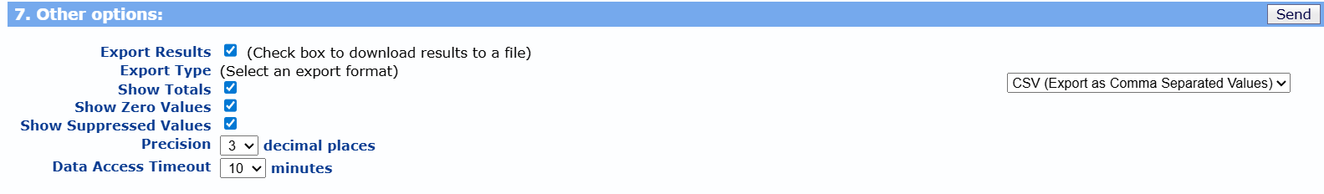

Here is a snippet of the downloaded CSV file
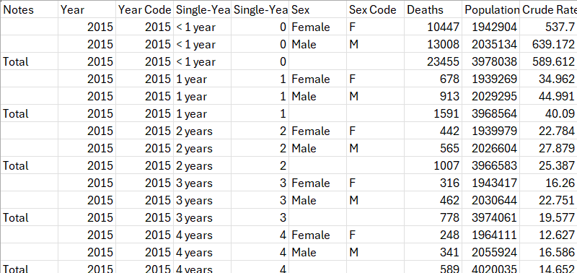
Note that death, population, crude rate shown for each group year, age=single-year, gender=sex. Also combined readings are shown for combined male and female. Furthermore, repeated values are shown. Further cleanup may be necessary.

Data Cleanup for Mortality Tables
Power query will be used
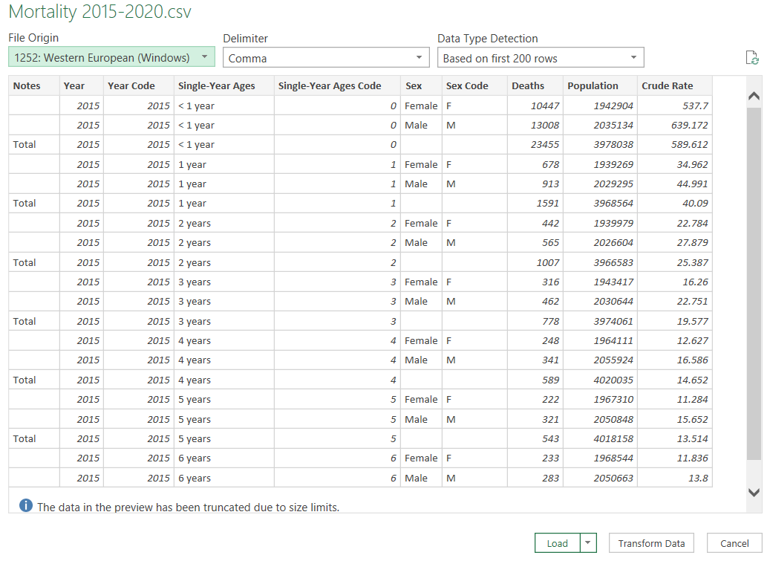

1.) Replace blank values to T which represents total
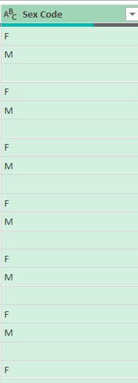
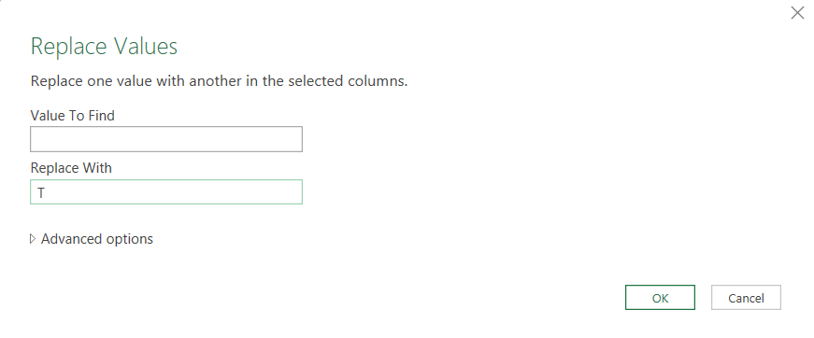
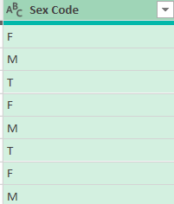

2.) Only keep Year, Single-Year Ages Code, Deaths, Population columns
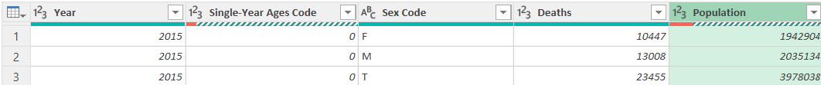

3.) We will only be looking at mortality from ages 20-84 so filter accordingly
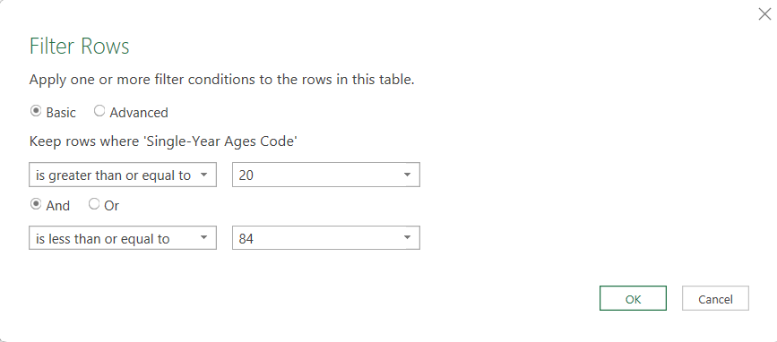
For all years there is no metric for Population for ages 85+. This is due to the privacy issues of older population (as age is past 85 the population becomes significantly lower which enables people to pinpoint individual deaths) and the variability of metrics themselves (population is unstably going down).

4.) Create necessary columns qx, and px with power query
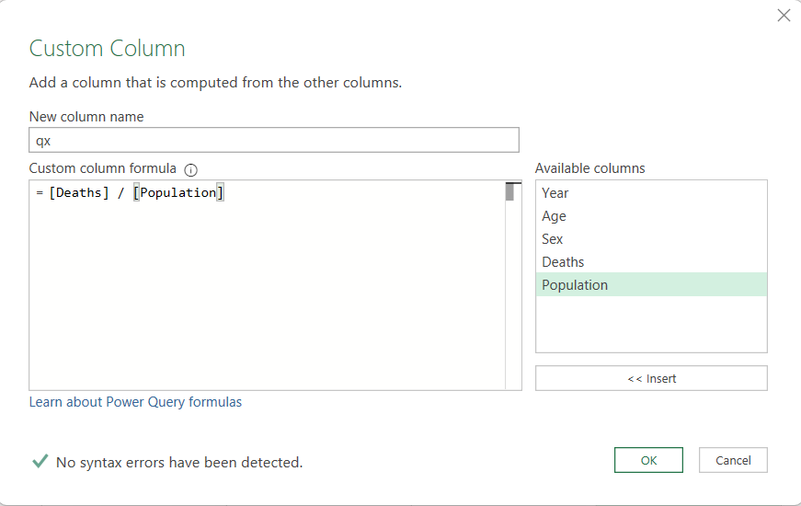
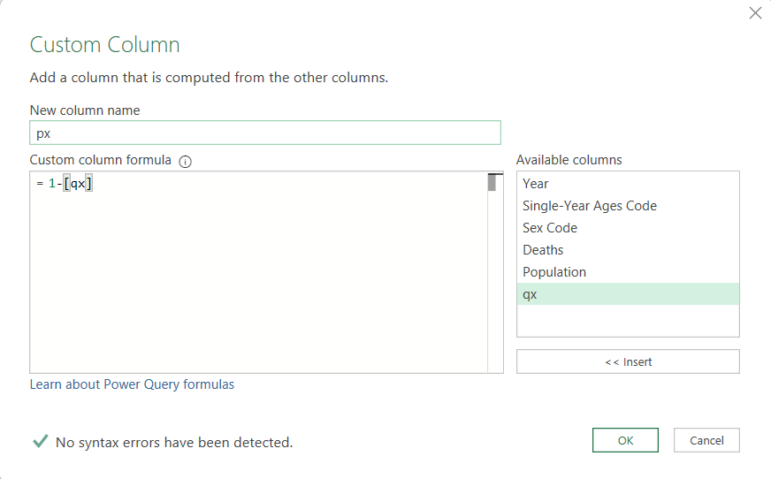
Note that qx and px are simple estimates for mortality. Our metrics qx and px derived from a dataset that is not longitudinal (following individuals over time). However, over large populations, the metrics we estimated tend to be accurate.

5.) Calculate lx: lx is a hypothetical cohort we assume to follow over their lifetime. We are synthetical creating longitudinal data.

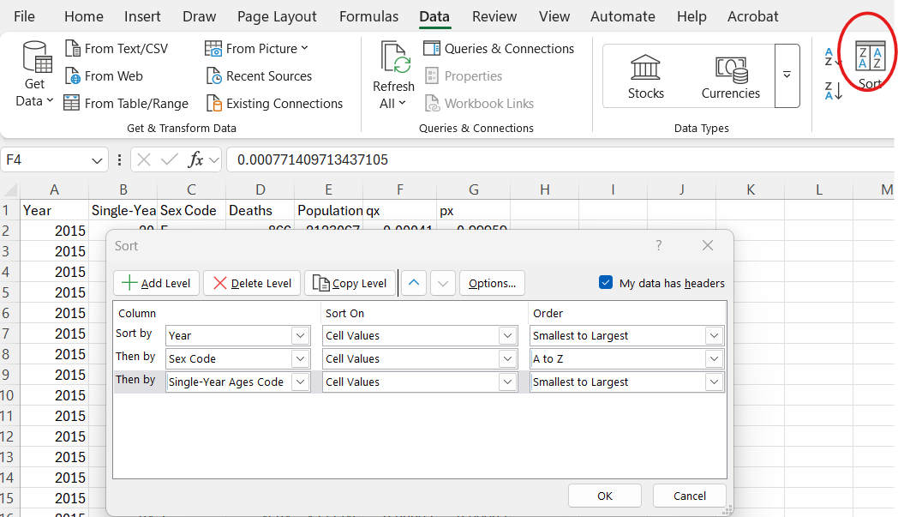
Use sort option to list out data sorted by year, sex, and by increasing age.

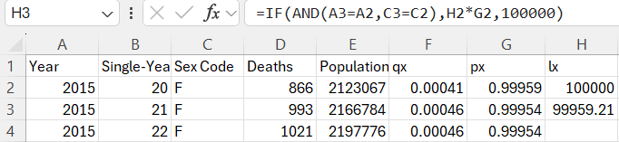
Since our dataset has categories for year, and sex we need the correct formula to recursively calculate subsequent lx’s given that we assume l20=100000. **100,000 is called a radix.**

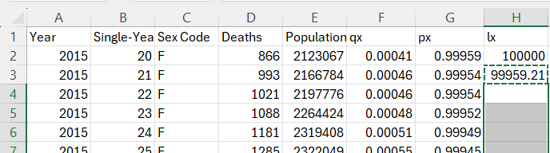
Copy and paste the formula down so it iteratively calculates down the line from age 20 to 84 for same categories of sex and year.

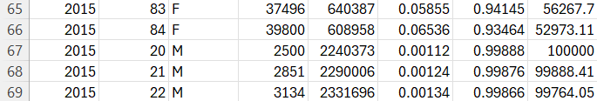
We can see that our formula is successful as it resets back to 0 for 2015 males.


Given qx and px estimated from a specific year, sex (or total), we are assuming 100,000 20 year olds of interest (since we assume cohorts lived to 20) are iterating through the same mortality cycles until 84 (since we don’t consider beyond age 84). So above example, we take 100,000 females through mortality patterns extracted from 2015. **It is very important to note that mortality patterns may vary across years. COVID19 impacts in 2021 may give significantly higher estimated px compared to that of a normal year like 2018**

6.) Calculate dx: how many of the proposed cohort died year to year consecutively. It also represents the expected number of death for 20+x to 21 +x year olds starting with100000 20 year old cohorts.

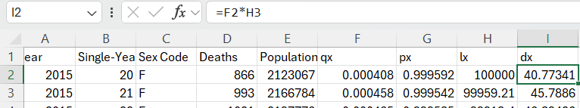
dx is just qx*lx.

7.) Calculate Lx: the mean total lived years between age x and x+1. We do not know when these individuals died exactly but that they died within that year. We are assuming all deaths in each year are uniformly distributed. For example, January has same deaths as February, March, etc. However, we as age increases death frequency may have a different distribution than uniform; older population may experience higher mortality rates during hotter months.

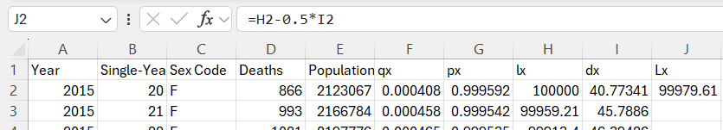
The equation for Lx is lx-0.5dx. The 0.5 will be different if distribution of death dx changes.

8.) Calculate Tx: Starting and hypothetical cohort of 100,000 lives at age 20, Tx measures the total remaining person-years lived by the survivors from age x to age 84. *Note this is not until death but until 84*

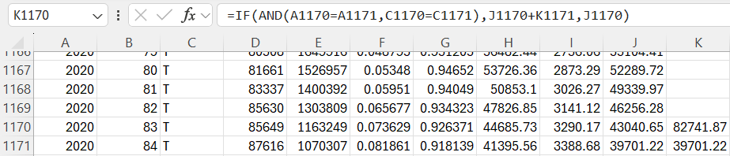
This type of calculation is backwards recursive. The above formula is correctly calculated based on different year and gender groups. Note that since direction is upward 1170 logic comes before 1171.

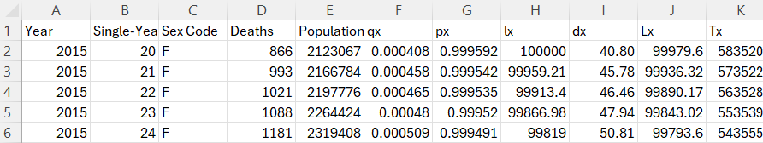
After pasting the formula logic, we get the correct total Tx values.

Essentially, the above calculations model the below logic.
T20 = L20 + L21 + L22 + ...
T21 = L21 + L22 + ...
T22 = L22 + ...

9.) Calculate ex: Represents the average future lifetime in years until age 84 for an individual given that they are x years old.

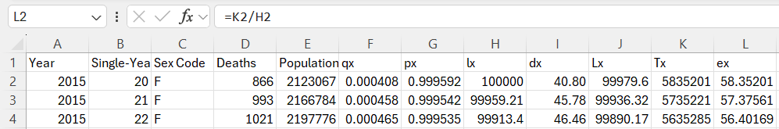
ex = Tx/lx

10.) Calculate Cumulative Survival: Represents proportion of survived x-year-old individuals from our hypothetical cohort of 100000 people (radix).

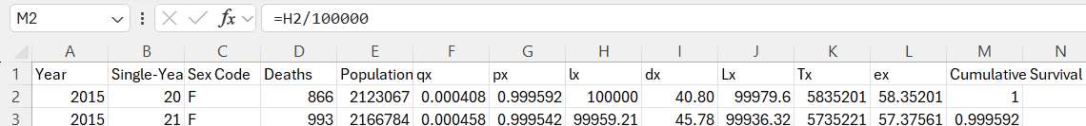
Cumulative Survival = lx/100,000

Pivot Tables and Visualizations
Turn our cleaned mortality dataset into a table.
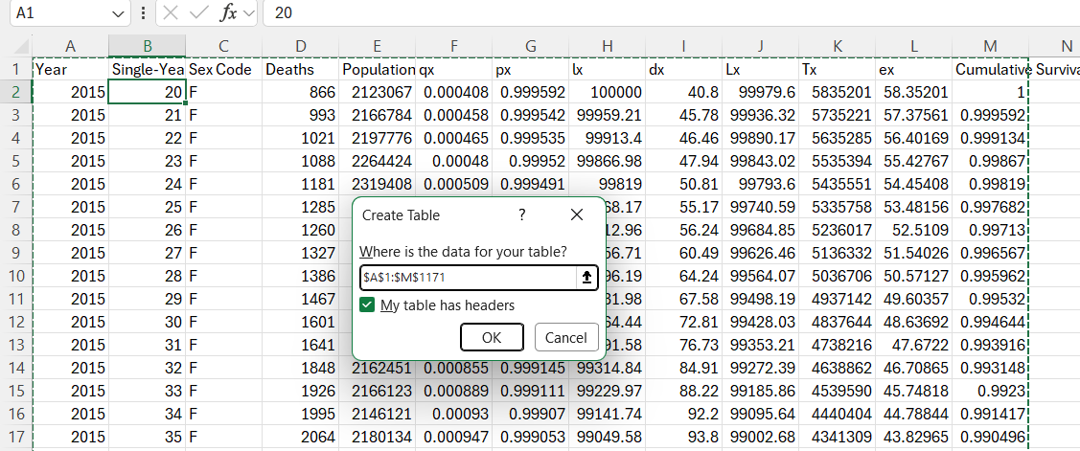
Table is created
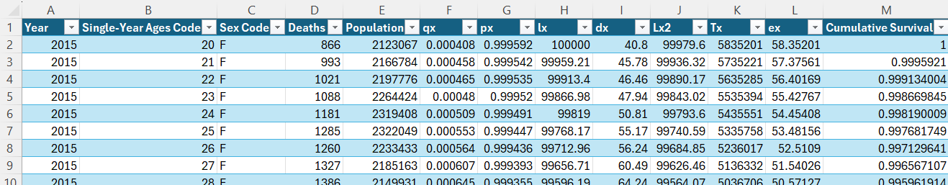

1.) Make Mortality Probability (qx) Line Graph
Use pivot tables
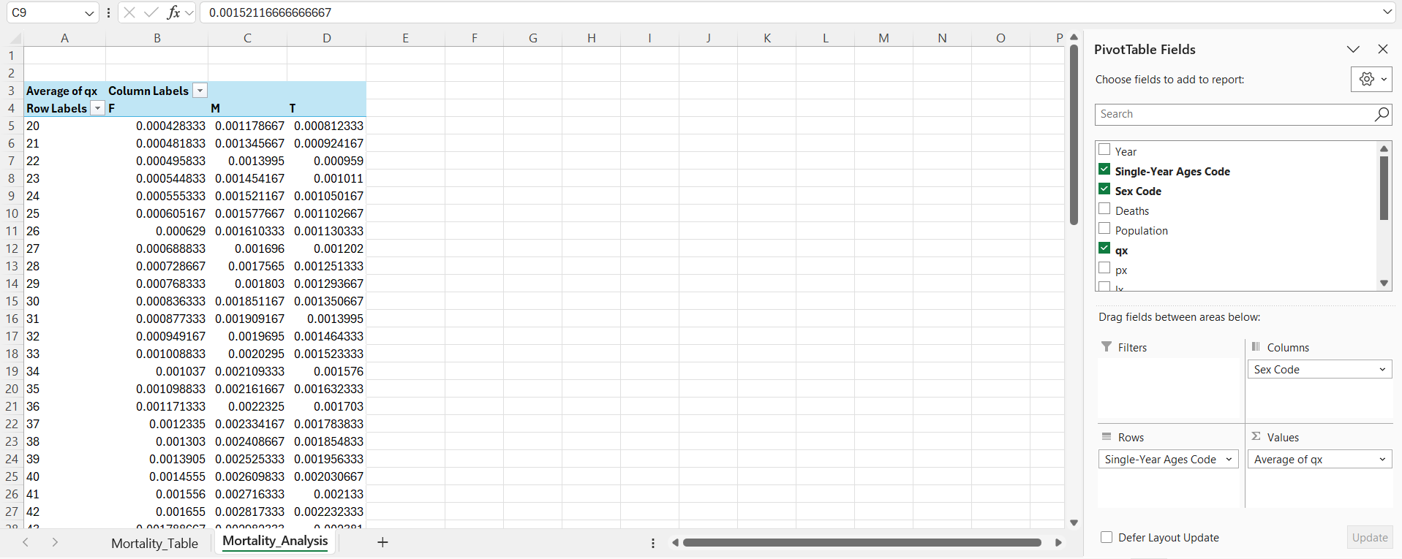

Put Sex as column, Age as row, and Average of qx for values.

Insert a 2-D line graph and adjust settings to best visualize

2.) Make Log Mortality Probability Line Graph
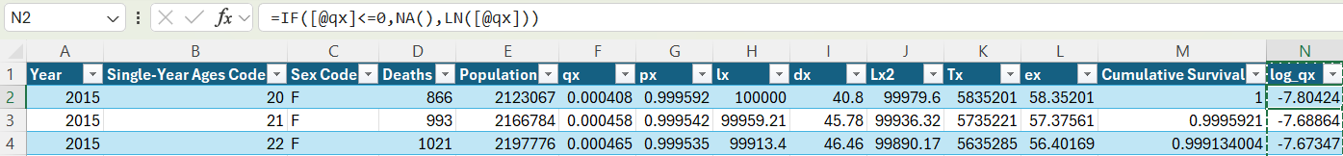
Take LN of qx to get the log estimated mortality rate.

Use pivot tables
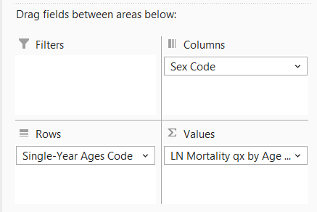

Same method as earlier

3.) Make Survival Curve

Use pivot tables
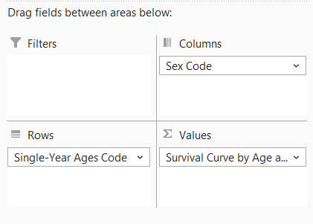

Same method as earlier

4.) Make Life Expectancy (ex) Line Graph

Use pivot tables
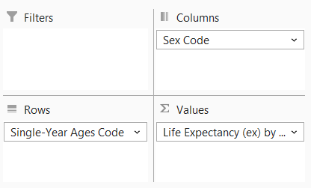

Same method as earlier

5.) Make Distribution for Death Rate

Use pivot tables
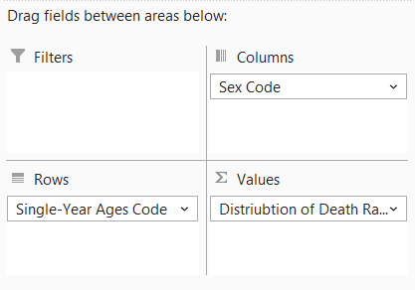

Same method as earlier

KPI and Dynamic Dashboard

1.) Add an age filter to all pivot tables so that we can see metrics for individual years from 2015-2020.
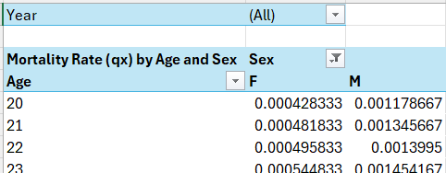
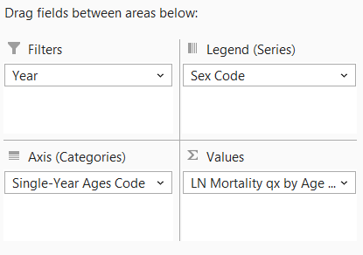

2.) Set up a logical dashboard with KPI cards that fit objectives. I am choosing life expectancy and survival by sex since they are the most intuitive metric for any audience.
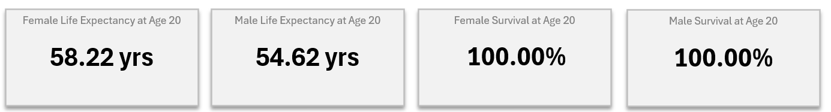

3.) Create a list from 20 to 84 then add a drag down using metric using data validation option referring to that list. Choose list and refer to the range of values as the source.
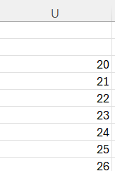

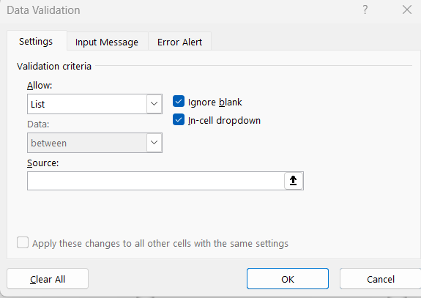

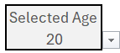
Redesign the drag down.

4.) Somewhere off to the side write formulas in formatted cells using xlookup to output the proper metrics.
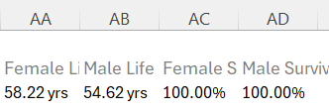
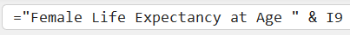
Note I9 is the drag down cell in my worksheet. Do for all KPI cards made.

5.) Reference the KPI cards to each of the cells created in step 4.
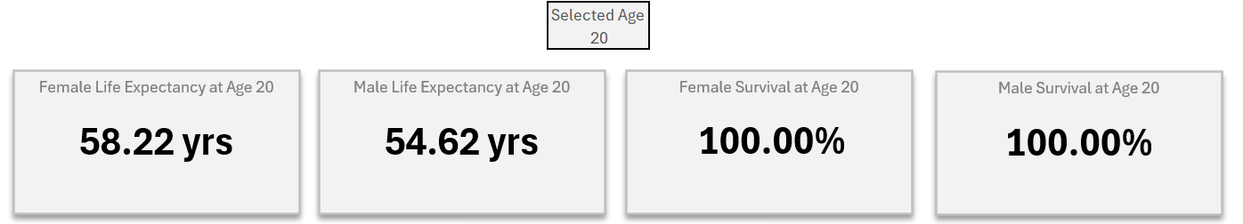

6.) Bring over the line graphs that match project objectives
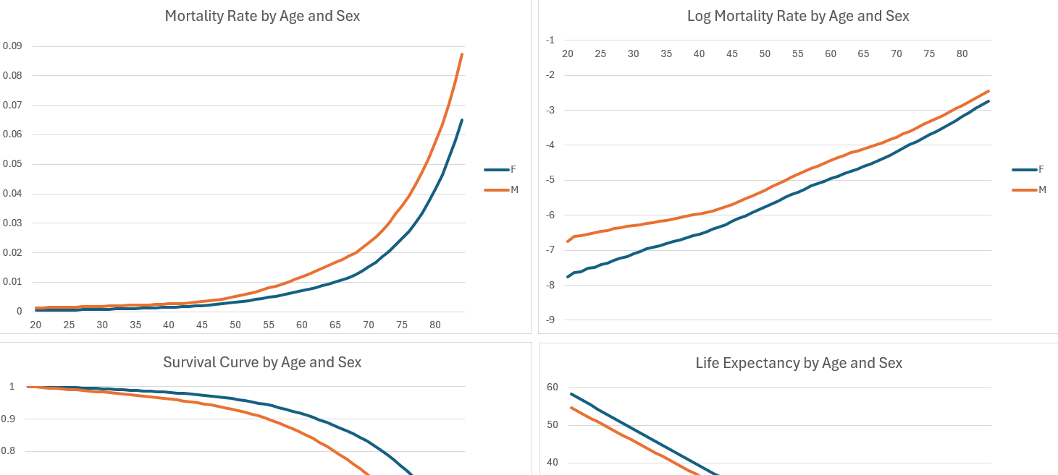
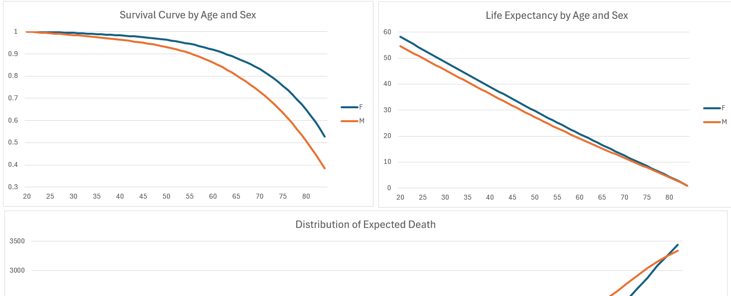

7.) Add a splicer for the year for one of the graphs and connect all pivot tables to the slicer.

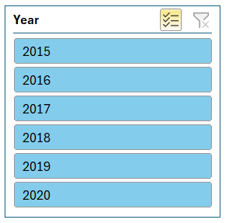
This will let you discriminate the graphs and the KPI cards based on the selected year/years.

9.) Organize the dashboard
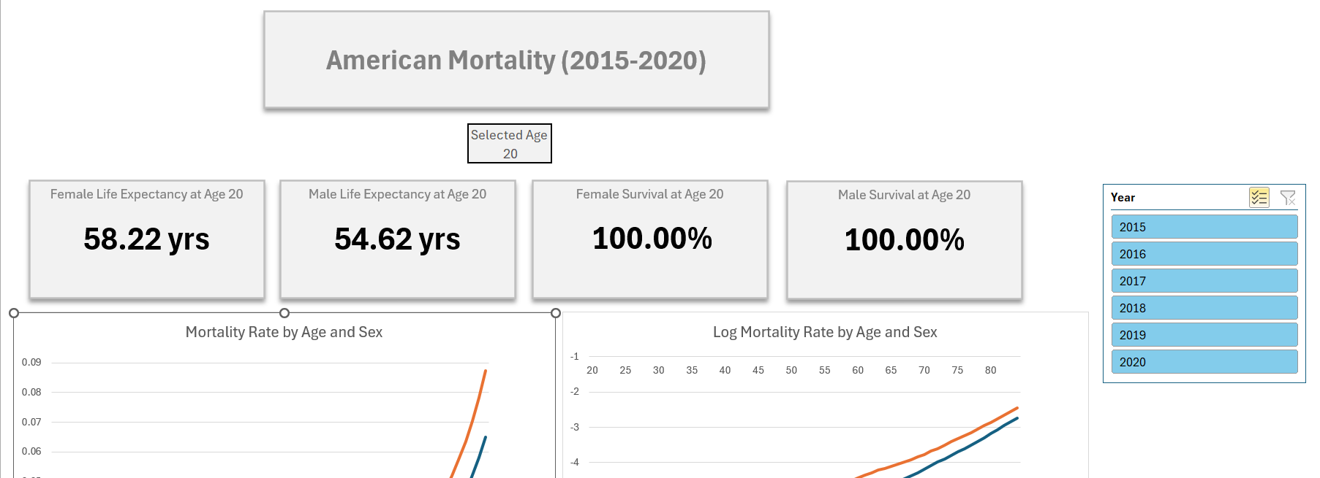

Modeling

1.) Starting Model

For the initial modeling process, we will take a specific subsection of our data metrics for females in 2019. Choosing 2019 is the most relevant without being impacted by COVID19 mortality shifts.

Our approximate qx using observed mx = deaths/population (also estimated since mx = deaths/exposure) will be reverted back to observed mx and log_qx also to ln_mx.
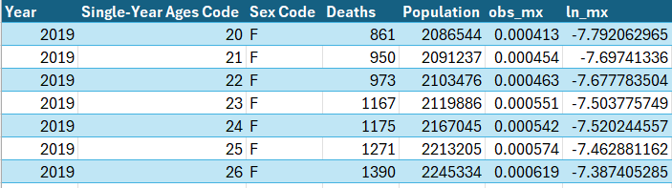
Gompertz Model
Gompertz Model proposes that death rate over age, mx, follows an exponential distribution. Therefore, the statistical model is based off mx = Bc^x where x = age, B = intercept constant, c = base constant.

Expanding further: ln(mx) = ln(B) + xln(c). We are assuming that then ln(mx) is linear. We are essentially fitting a single-variate linear regression model where we assume y = ln(mx), beta0 = ln(B), and beta1 = ln(c).

Excel
Highlight column for age and ln_mx and insert a scatter plot
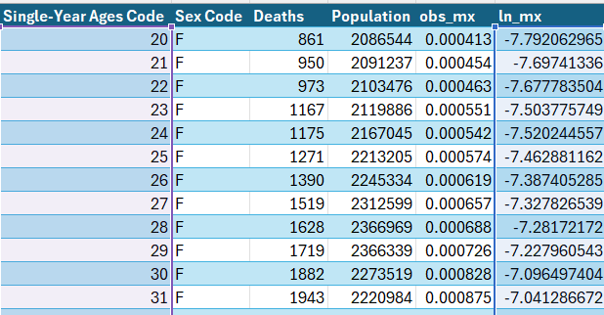

Add trendline and select yes for equation and R^2 option.

From this scatter plot, we see ln(B) = -9.4884 and ln(c) = 0.0761. R^2 is 0.992 meaning that our linear model explains 99.2% of total variance.

Reverting to B and c by taking exponents of ln(B) and ln(c)
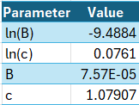
We interpret c as the percentage increase yearly percent increase. Since c=1.07907, we assume that mortality grows around 8%.

Create a new column called fitted_mx
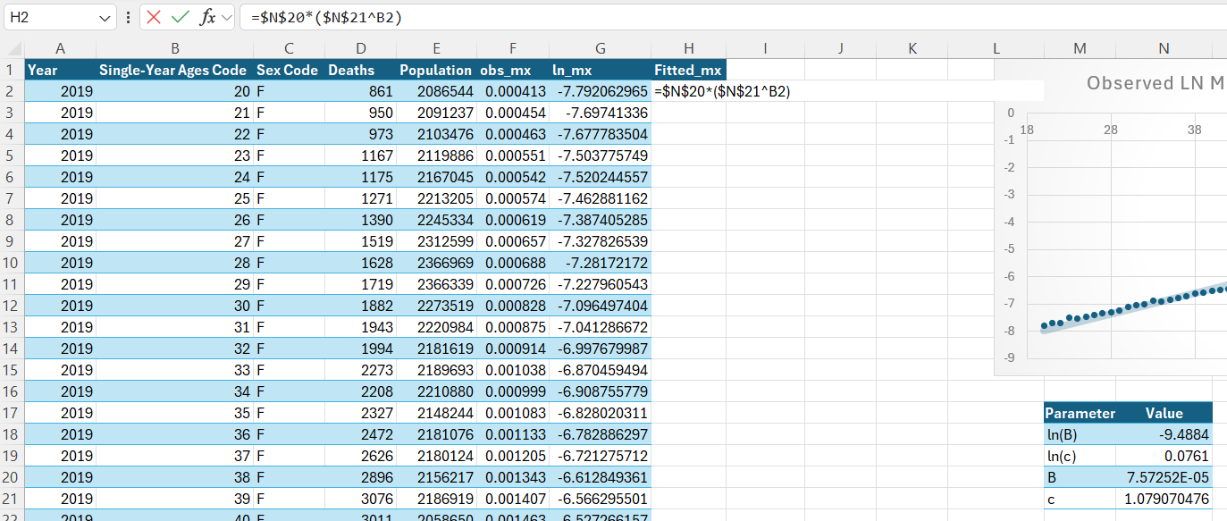

Create another column called fitted_ln_mx
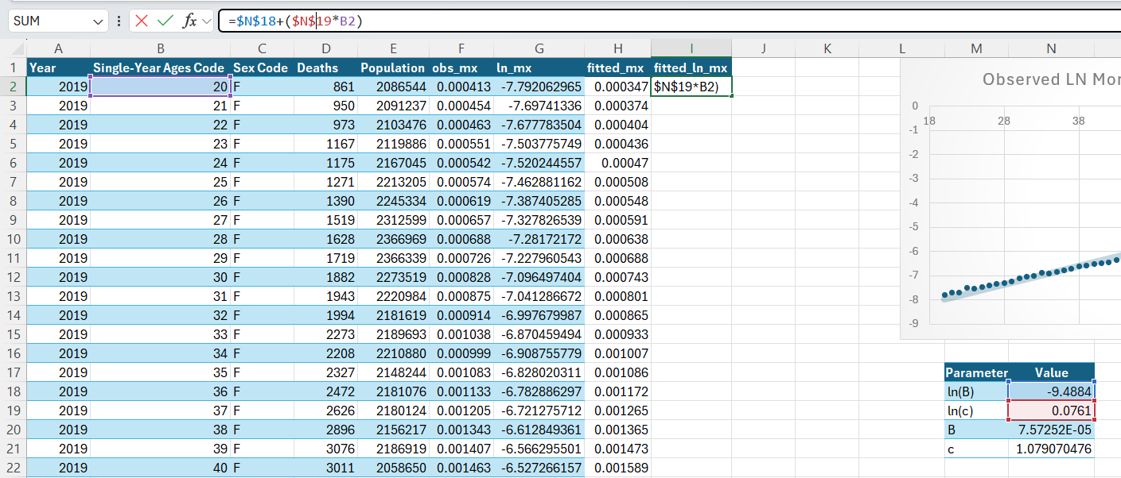

Highlight Age, obs_mx, fitted_mx and create appropriate 2-line graph
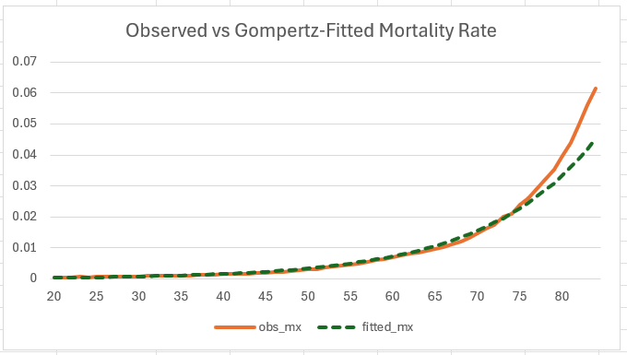
The most important insight here is that the Gompertz model matches well from ages 20 to 75 but it seems to underestimate the observed mortality rates for ages 75+. Note this is based only on females in 2019.

Next create a residual column so we can graph the residuals
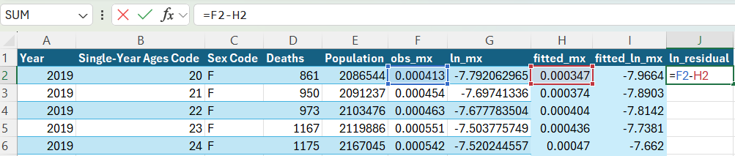

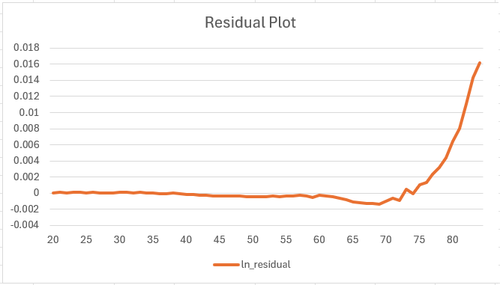
Residual plot substantiates the previous observation.

2.) Mortality Graduation

Before moving further towards more advanced models like Lee-Carter, we need to understand the fundamental process of graduation. Mortality rates are bound to have unexpected fluctuations that veer away from the general trend line. Graduation process smooths the mortality curve so that it adapts better to overall patterns. Therefore, while Gompertz is a parametric modeling process, graduation is non-parametric
Moving Average
The 3-year moving average replaces each age-specific mortality rate with the average of the current age and its adjacent ages, while the 5-year moving average averages the current age with the two neighboring ages on either side.

For 3-year moving average: ex) Smoothed mx for Age 21 = AVG(obs_mx for Age 20, 21, 22). Note that for 3-year MA, first and last rows will be averaged using two values: itself and the nearest adjacent age.

1. 3-year MA Excel
For 3-year moving average: ex) Smoothed mx for Age 21 = AVG(obs_mx for Age 20, 21, 22). Note that for 3-year MA, first and last rows will be averaged using two values: itself and the nearest adjacent age.

Take the averages of adjacent values from age 21 to 83.
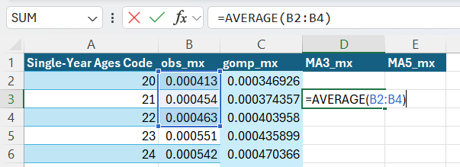

Take the average of obs_mx for age 20 and lower adjacent age of 20 for age 20. Take the average of obs_mx for age 84 and upper adjacent age of 83 for age 84.
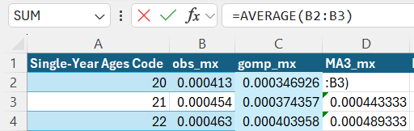
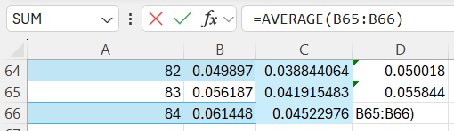

2. 5-year MA Excel
For 5-year moving average: ex) Smoothed mx for Age 22 = AVG(obs_mx for Age 20, 21, 22, 23, 24).

Take the averages of 2 adjacent values from age 22 to 82.
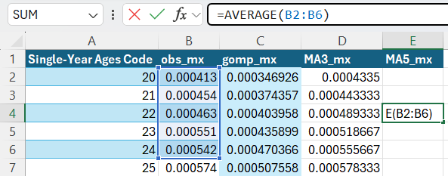

Take the averages of first 4 for age 21, averages of first 3 for age 20, the last 4 for age 83, and the last 3 for age 84
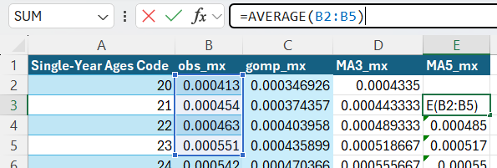
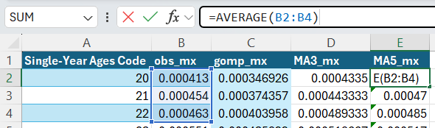
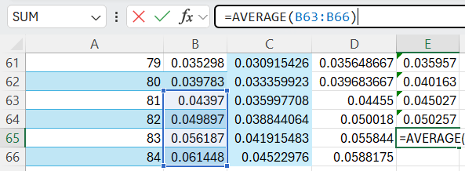
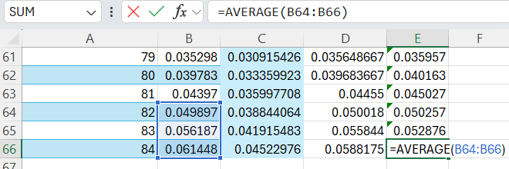

Using the same method as earlier graph obs_mx, gomp_mx, MA3_mx and MA5_mx against age.
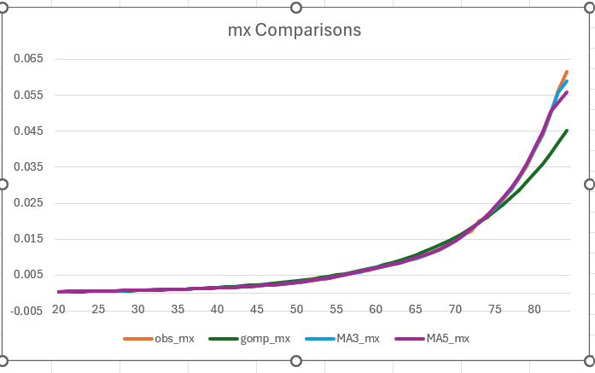
MA5 and MA3 seem to underestimate mortality at the tail end. MA5 starts diverging early while MA3 diverges slightly later.

Now plot all the residuals for all our mx curves to compare the deviations from the observed mx. Use the same process as earlier.
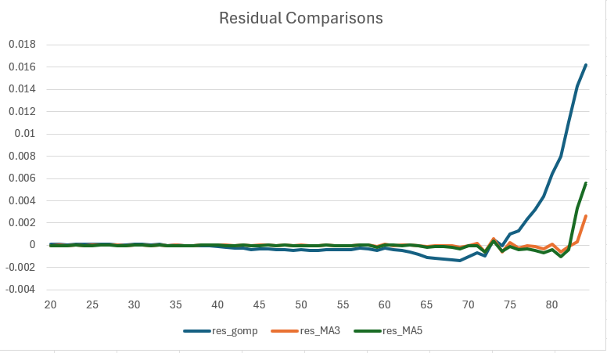
Same patterns as discussed above.

To see the relative change a % difference residual plot was made.
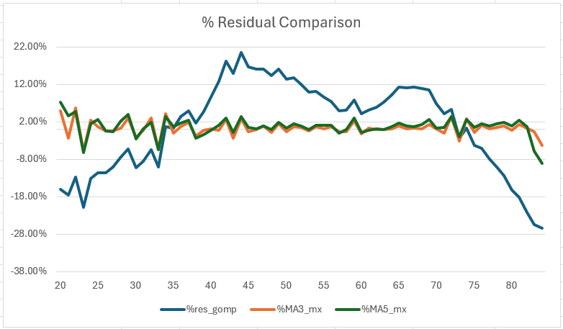
3.) Mortality Improvement over Time

Create pivot table with the following specifications.
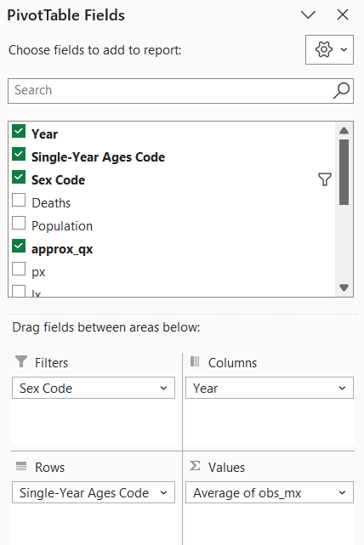

Then conditional format the numeric sections from green-yellow-red.
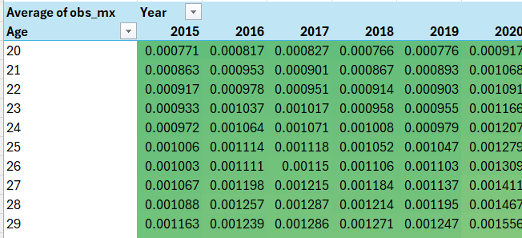
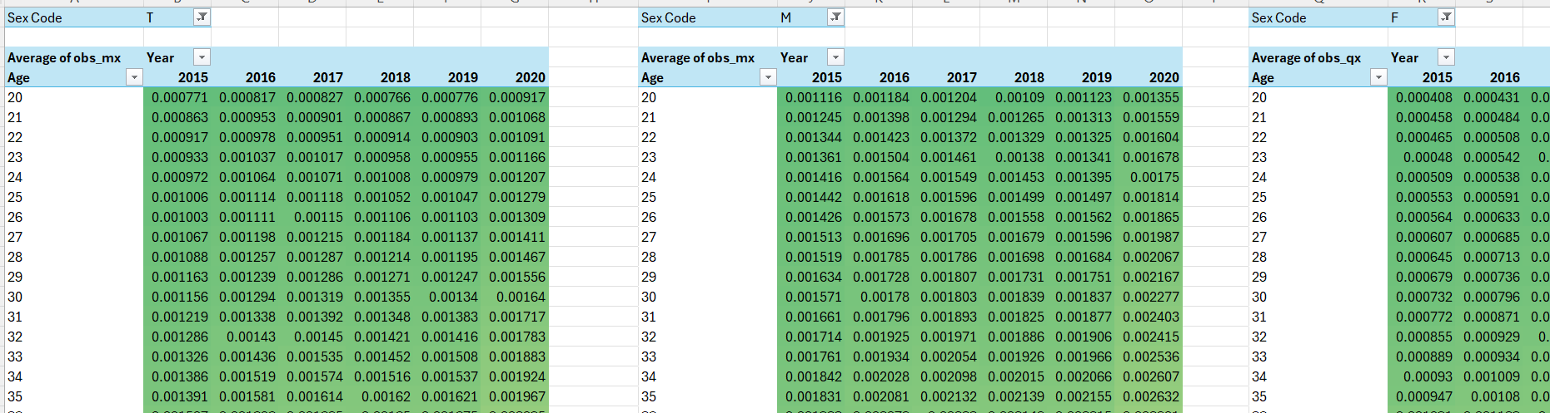

Now create another table where we calculate the percent increase from the previous year from 2015-2020.

This table is for total observed mortality rate.
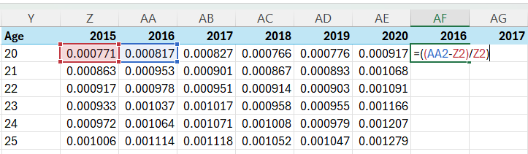
Repeat for all years from 2017-2020.

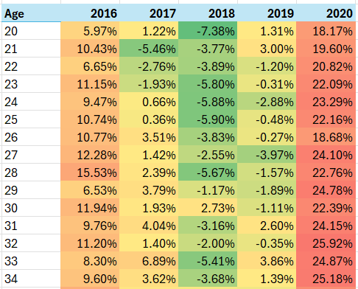
We can see that the pattern is obviously pointing to mortality rate increase compared to 2019 to 2020. These are the effects of COVID19.

Repeat for all male and female tables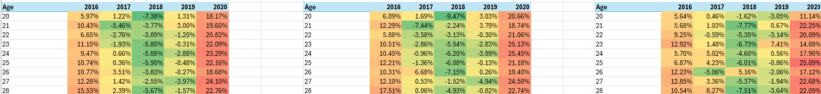

Create meaningful graphs
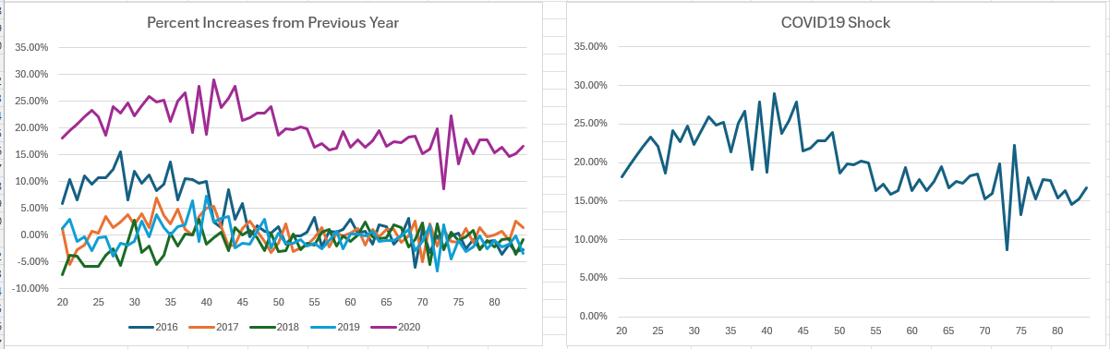

4.) Gompertz Extended

We saw from the Gompertz modeling process that late age mortality was underestimated using the standard linearized ln(m(x)) = ln(B) + xln(c). Makeham model proposes that there is another background or underlying mortality constant A. Now Makeham model is m(x) = A + B * c^x.

Makeham Model
We are given m(x) = A + B * c^x. A represents a background risk of death. Since we are adding another unknown parameter, we cannot linearize the formula without being given the A. Makeham requires minimizing for the 3 parameters using alternative methods besides OLS method.

Parameter Search Excel
To estimate the parameters, will start with a reasonable guess given our gompertz parameter estimations.
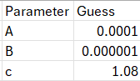

Using these above initial guesses create a proposed mx column.
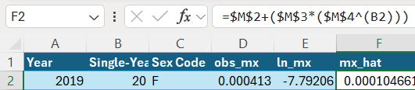

Then take the LN of this proposed mx column.
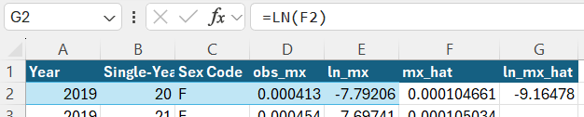

Take the residual of the ln mx’s.
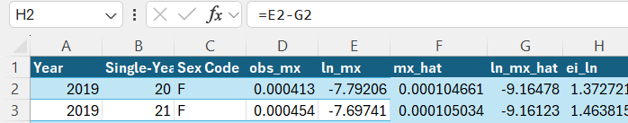

Square the residuals then add squared values to get RSS.
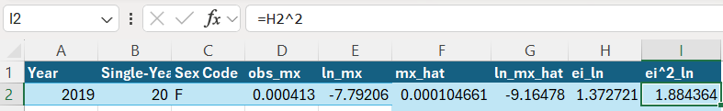
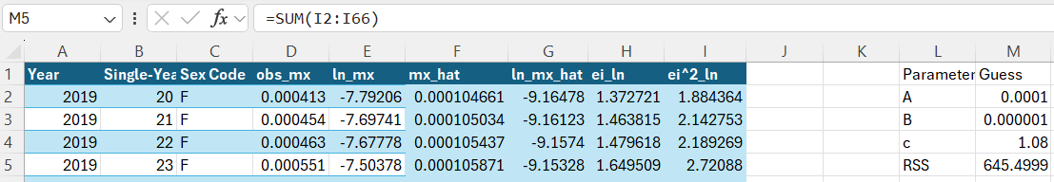

Next we use Excel’s solver to find the best parameters
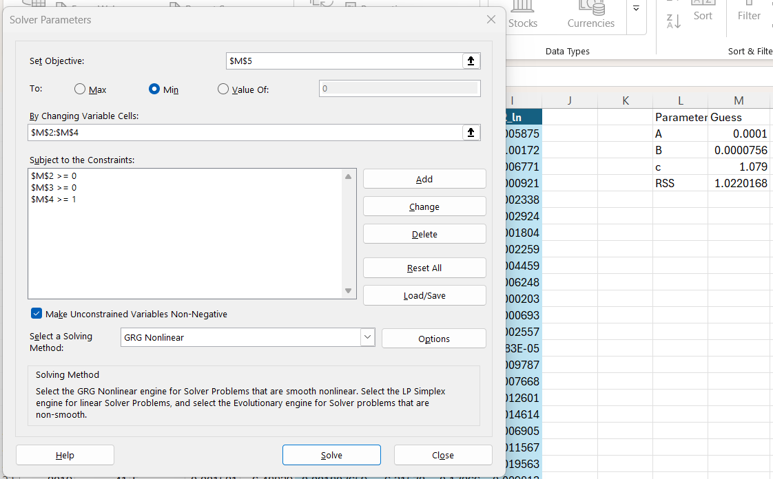
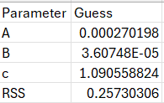
What Excel Solver is doing is essentially a simplified version of the Gauss-Newton/Newton-Raphson family of nonlinear least squares algorithms. We get optimized parameters with minimized RSS.

Create another column for ln(mx-A) to see the Makeham model as a linear plot.
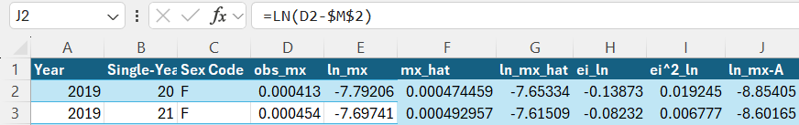
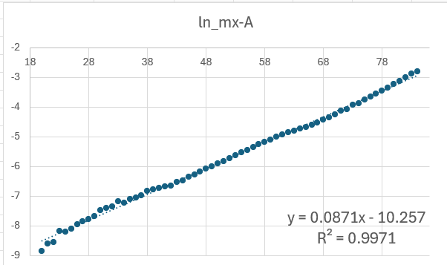

Now create ln_mx plots to visualize performance.
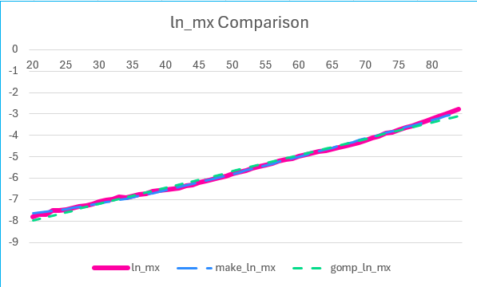
Create relative residual plot as well. Using obs_mx – fitted_mx/obs_mx as formulas.
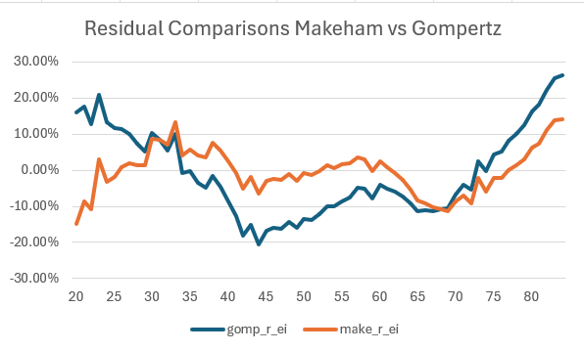

A simple parameter comparison chart was made
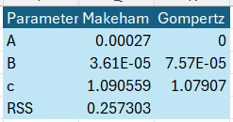

5.) Graduation Extended

Beyond a simple moving average graduation, there is another method of curve smoothing that actuaries use.

Whittaker-Henderson Graduation
Given a predetermined window for age and constant for penalty, the algorithm penalizes second difference.
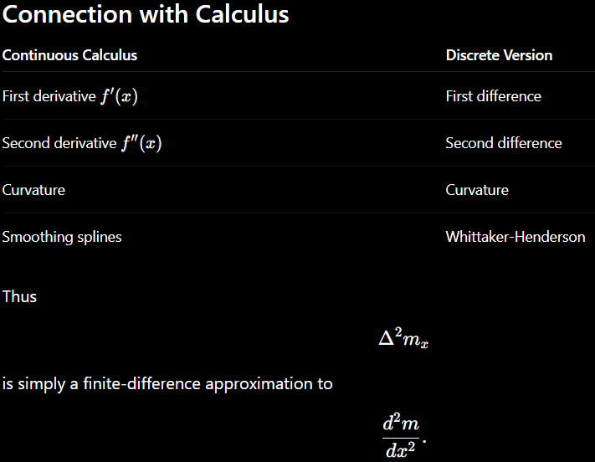

Second difference measures curvature therefore the squaring will give the magnitude of the deviation from the smooth curve. However, for our purposes, we will smooth mortality.

Load the same columns obs_mx, ln_mx, etc from previous tables. Then for now keep WH_ln_mx with the same values as ln_mx. Keep the formula as (ln_mx-WH_ln_mx)^2 as ei^2 (if WH_ln_mx changes then it will change). Add second difference and the square of the second difference.
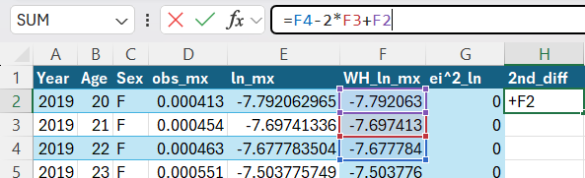

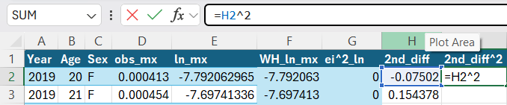

Then essentially do a penalized (on square of second difference) least square regression (a.k.a. Whittaker-Henderson Graduation) which requires minimization of our objective function: RSS + lambda*2nd_diff^2.
Create a parameter table for our solver. Set lambda as 100 (penalty constant for roughness). The higher the lambda the more penalty for roughness. Also use formula below to calculate RSS which should be zero for now.
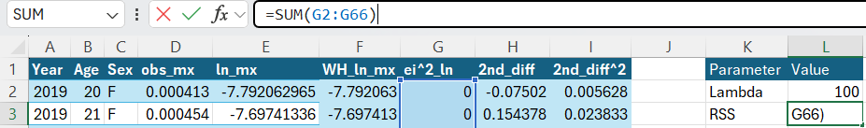

For Roughness which is formula below
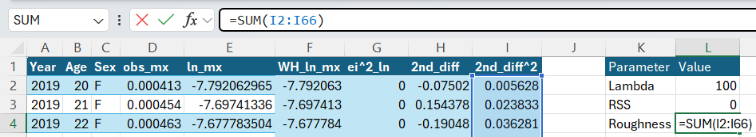

For our objective function RSS + lambda*2nd_diff^2 use formula below
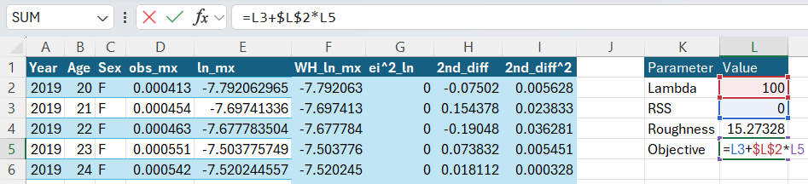
Note that lambda should stay as constant.
Create an additional column that is the Whittaker smoothed ln mortality converted back to original rate.
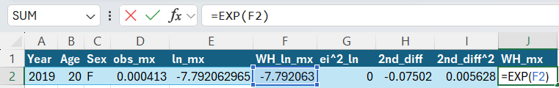

Now minimize our objective using the solver. Use constraint $F$3:$F$66 >= $F$2:$F$65 in solver which just means y(x=1) >= y(x). Mortality for given age +1 will always be higher than that of given age.
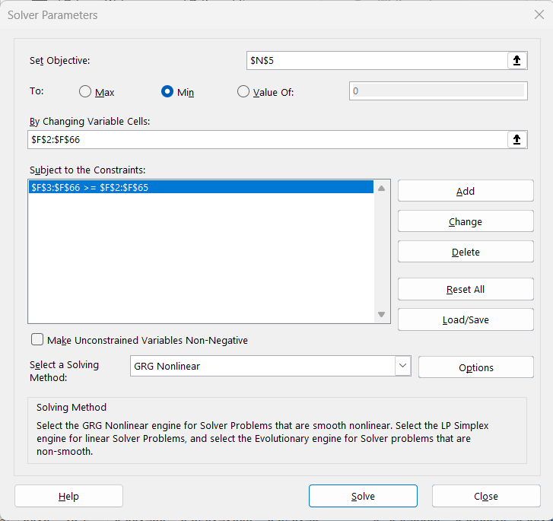
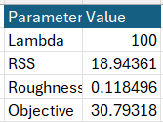

Column for WH_ln_mx will change once the solver runs. Now we can test a range of lambdas to find how the graduation changes given penalty term.
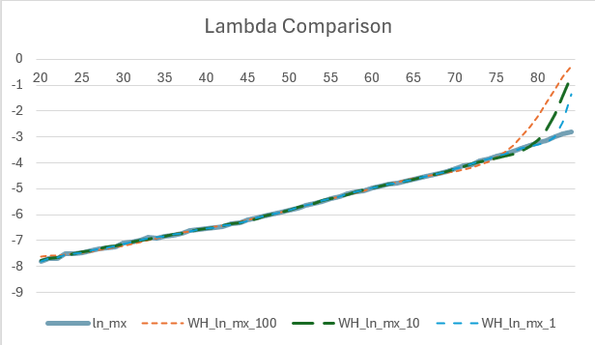
Lambda 1 seems to be the best fit here. Also, WH graduation seems to be overestimating at the final ages as second differences become more volatile at later ages.

To make the best fit and smooth line, lambda value of 1 will be used and final 2 values from the Makeham fitted values will be replace the Whittaker values to stabilize the fit.
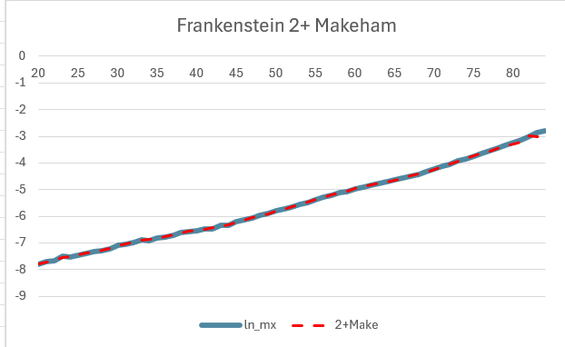
Very close to the obs_mx.

Below is the relative residual plot between Makeham and Whittaker. Last two ages 84 and 83 were omitted since Whittaker fitted values went out of control.
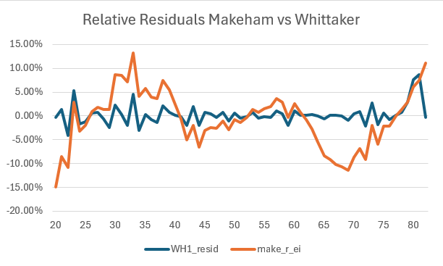
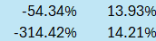
Besides the last two ages, the blue line seems to better oscillate around 0% meaning that Whittaker-Henderson is effectively smoothing the mortality curve.

